0.

Cod JS

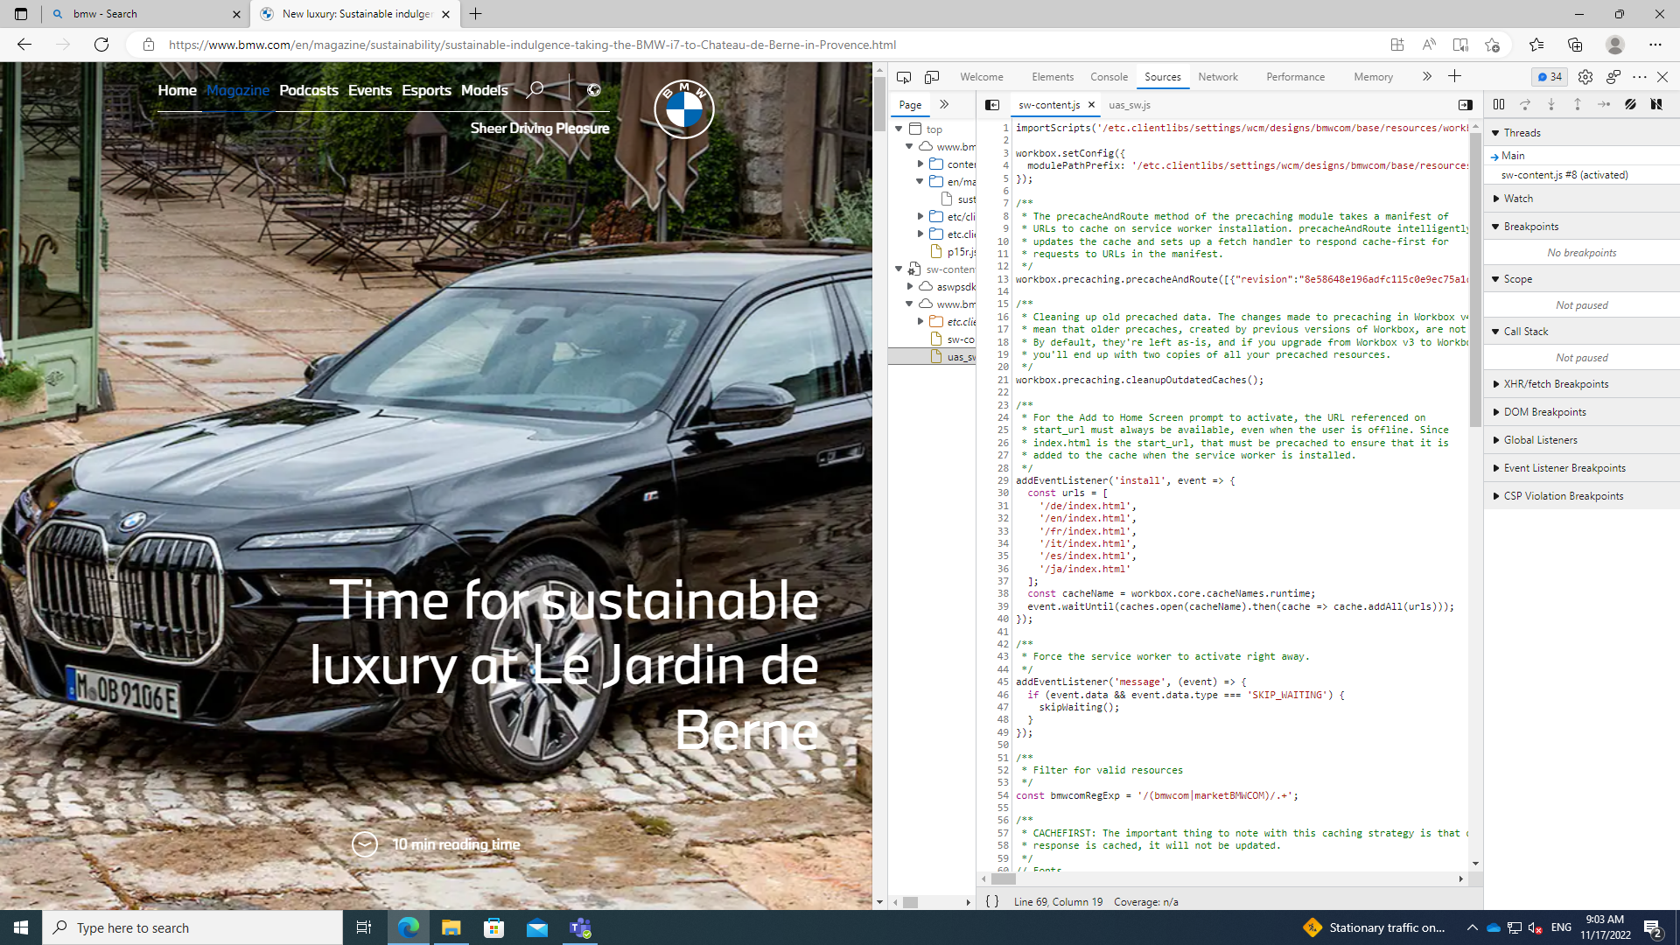

Ex2 ,ex3: https://github.com/Shaster26/Tema_IA_Unit2_Lab7.git